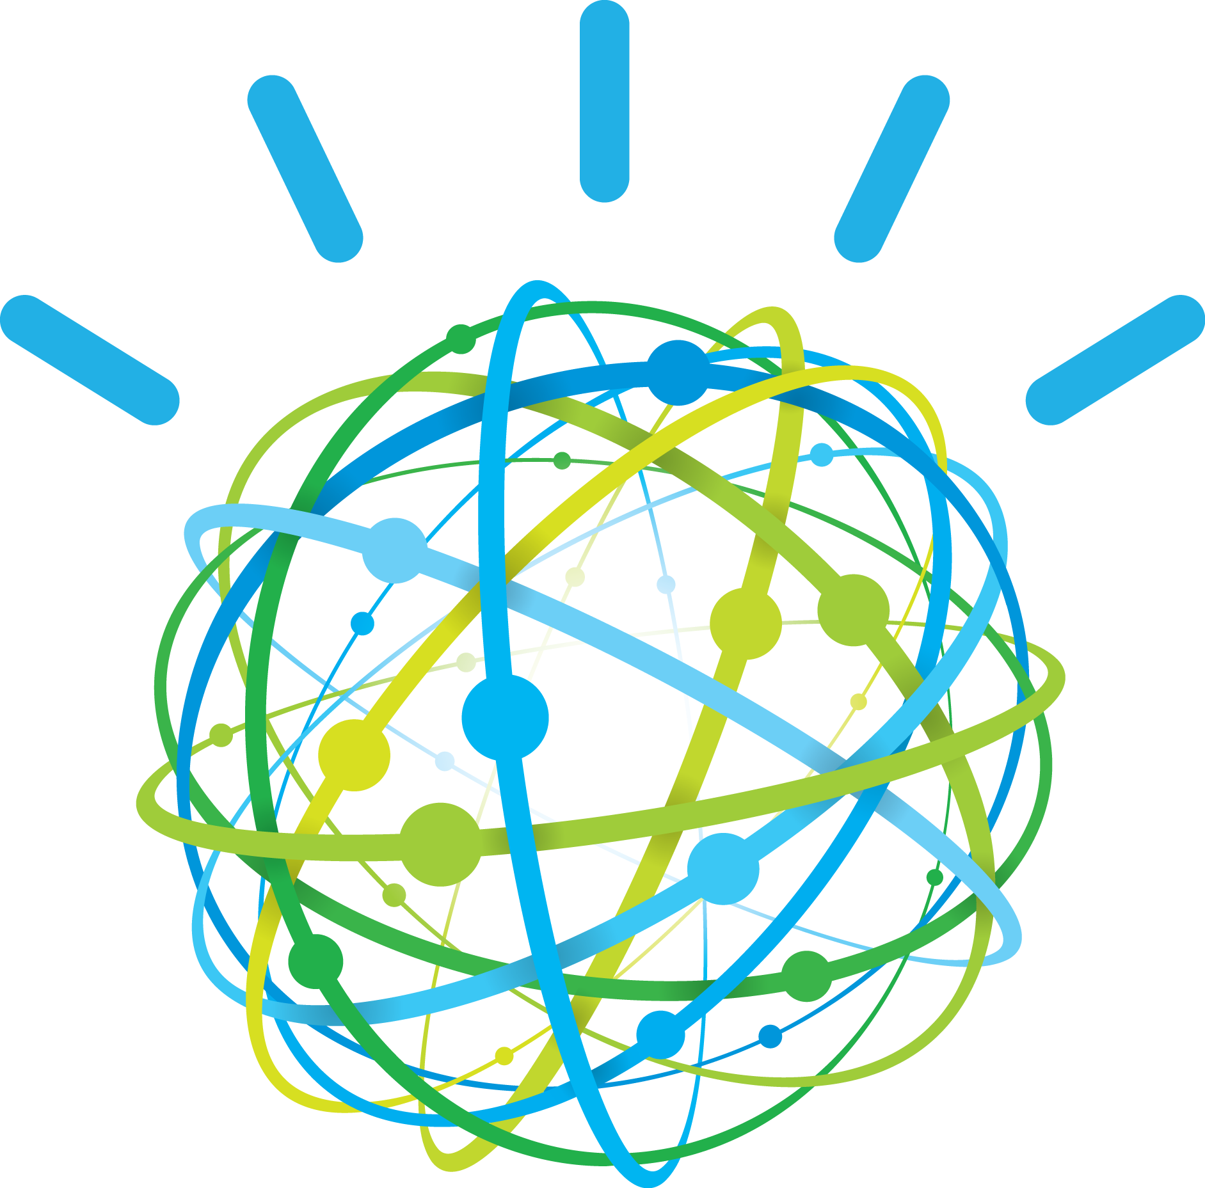

Session 1: Getting Started

IBM Watson Conversation

**Mobile**

**Content**

Let’s get started 3

1. Overview 3

2. Objectives 3

3. Prerequisites 3

4. What to expect when you are done 3

Create an IBM Cloud Account 4

5. IBM Cloud Account 4

Apply a promo code 6

6. Get more resources 6

7. US south CF Space creation 8

Install the Cloud Foundry command-line Interface 10

8. CF installation 10

Install Node.js and Express 11

9. Node installation 11

# Let’s get started

### Overview

The [IBM Watson Developer Cloud](http://www.ibm.com/smarterplanet/us/en/ibmwatson/developercloud/) (WDC) offers a variety of services for developing cognitive applications. Each Watson service provides a Representational State Transfer (REST) Application Programming Interface (API) for interacting with the service. Some services, such as the Speech to Text service, provide additional interfaces.

The [Watson Conversation](http://www.ibm.com/watson/developercloud/conversation.html) service combines several cognitive techniques to help you build and train a bot - defining intents and entities and crafting dialog to simulate conversation. The system can then be further refined with supplementary technologies to make the system more human-like or to give it a higher chance of returning the right answer. Watson Conversation allows you to deploy a range of bots via many channels, from simple, narrowly focused bots to much more sophisticated, full-blown virtual agents across mobile devices, messaging platforms like Slack, or even through a physical robot.

The **illustrating screenshots** provided in this lab guide could be slightly different from what you see in the Watson Conversation service interface that you are using. If there are colour or wording differences, it is because there have been updates to the service since the lab guide was created.

### Objectives

In this lab, you will:

* Learn how to get started with IBM Cloud
* Learn how to install the Cloud Foundry command-line interface
* Learn how to configure your workstation for IBM Watson Node.js development

### Prerequisites

None

### What to expect when you are done

You should have an environment ready for the labs.

# Create an IBM Cloud Account

IBM Cloud is a platform-as-a-service (PaaS) that allows you to create your own application mashups using a variety of runtimes and services. The cognitive services offered by the IBM Watson Developer Cloud are made available in IBM Cloud. So, before you can begin building cognitive applications, you will need to create your own IBM Cloud account.

### IBM Cloud Account

1. In a web browser, navigate to the following URL:

<https://www.bluemix.net/>

or

|  |  |
| --- | --- |
| **Location** | **URL** |
| US south | <https://console.ng.bluemix.net/> |
| US East | [https://console.us-east.bluemix.net](https://console.us-east.bluemix.net/) |
| UK | <https://console.eu-gb.bluemix.net/> |
| Sidney | <https://console.au-syd.bluemix.net/> |
| Germany | <https://console.eu-de.bluemix.net/> |

1. Click **Create a free account**

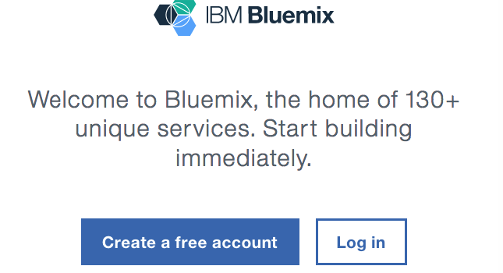

1. You will be taken to the account creation page. On this page, you can review the terms of the trial and review the IBM Cloud privacy policy. Fill out the form and click **Create Account**. If you do not already have an IBM ID, this process will create one automatically for you.
2. After you submit your registration, you will receive an e-mail from the IBM Cloud team. In this e-mail, you will need to click the link provided to confirm your registration.
3. That’s it! You now have a lite IBM Cloud! At this point, you can log in (using the URL in step 1) and begin exploring it’s features and capabilities.
4. During the first step, you must define your organization name, and the data center region. At this stage, you might not be able to select a region and use the preselected one.

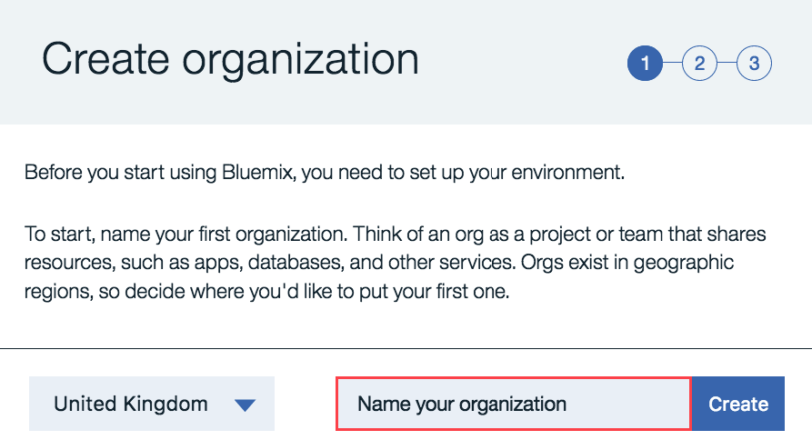

1. Click **Create**
2. Name your space
3. Click **Create**

Then the workspace is ready.

1. Click **I’m Ready**

# Apply a promo code

The lite account is provided to test IBM cloud features for free. Unfortunately, We must get more resources to run all labs of this session. In order to get them, you are going to apply a promo code.

### Get more resources

1. select **Manage / Billing and Usage / billing** menu

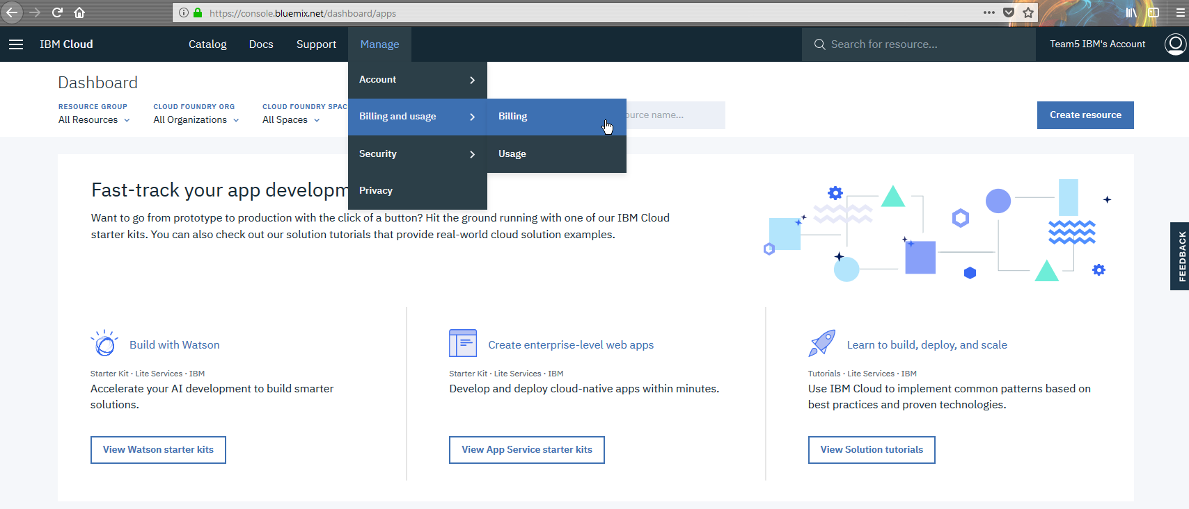

1. Scroll down and click **Apply Code**

The code should be provided by the main intervenant.

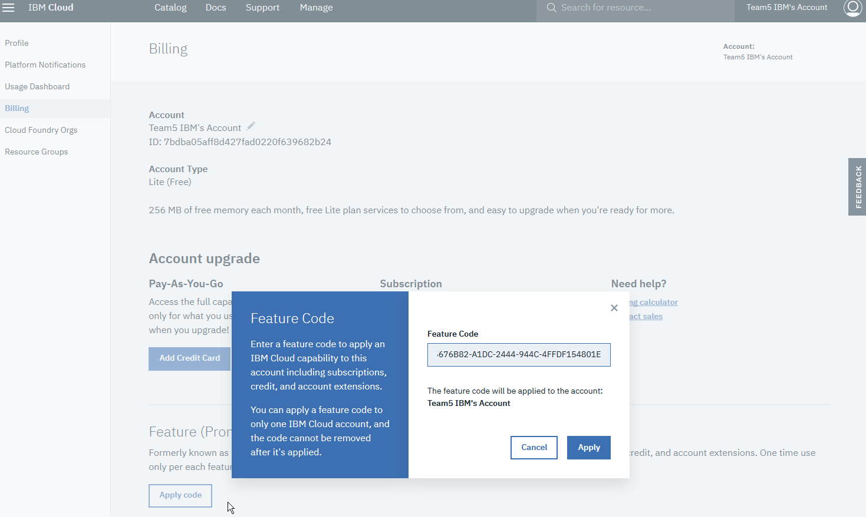

1. Enter the code then click **Apply.**

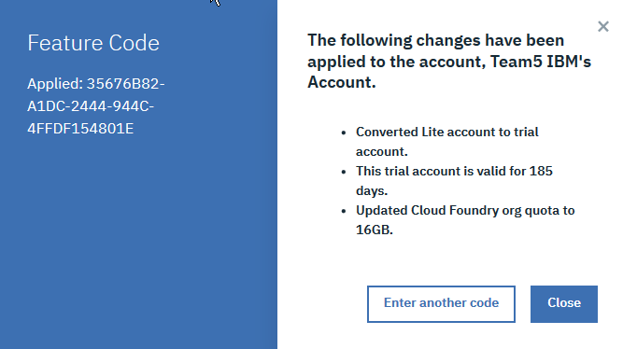

### US south CF Space creation

Some labs require to create services in US south region

1. Select **Account / Cloud Foundry Org** menu.

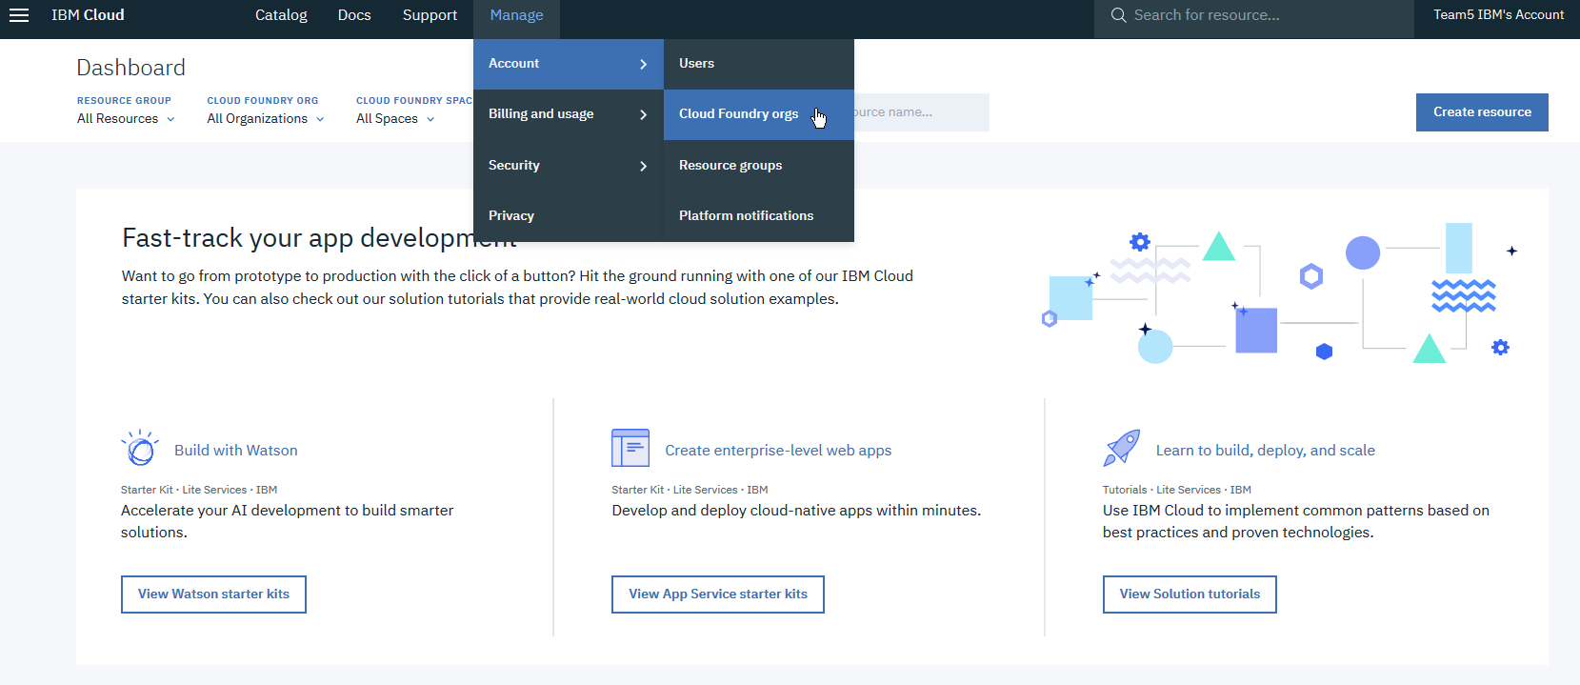

1. Click on your organisation row

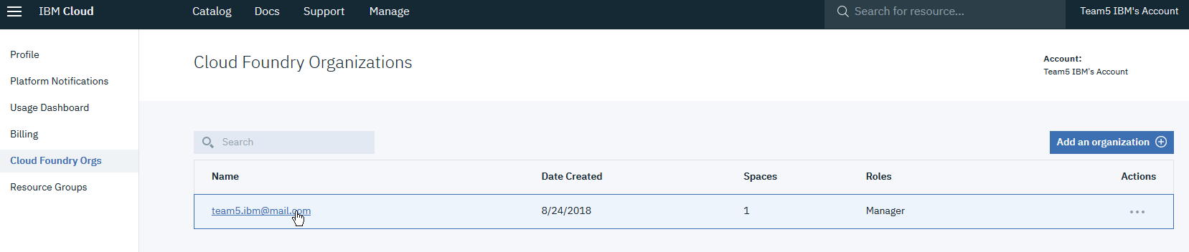

1. On the right, click **Add a space** then select US South as region and enter a name for your space

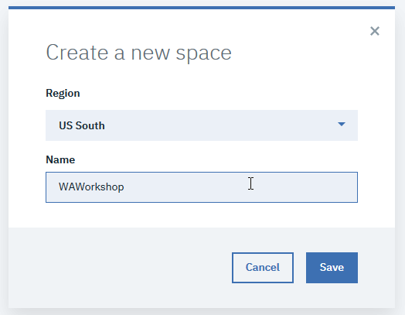

Then you should have:

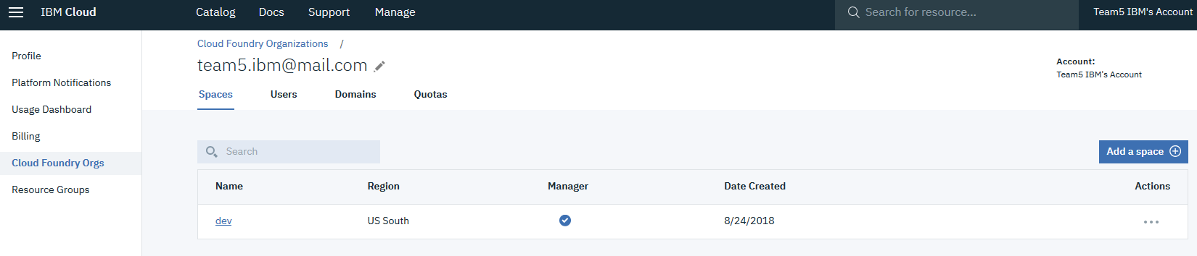

# Install the Cloud Foundry command-line Interface

You can manage your applications in an IBM Cloud environment using the Cloud Foundry command-line interface (CLI). Using this tool, you can deploy your applications to IBM Cloud, create and bind services to your applications, manage authentication credentials, and more.

### CF installation

1. In a web browser, navigate to Cloud Foundry CLI downloads page.

<https://github.com/cloudfoundry/cli/releases>

1. Download and install the latest version of the tool on your local workstation. The procedure may vary according to your operating system
2. Review the [documentation](https://console.ng.bluemix.net/docs/cli/reference/cfcommands/index.html) to become acquainted with the most common commands

# Install Node.js and Express

Node.js is an open-source, cross-platform runtime environment for developing server-side web applications using JavaScript. Node.js has an event-driven architecture capable of asynchronous I/O utilizing callbacks.

Express is a minimal and flexible Node.js web application framework that provides a robust set of features to develop web and mobile applications. It’s ability to facilitate rapid development of Node based web applications makes it the de facto framework for Node.js.

### Node installation

1. In a web browser, navigate to the Node.js homepage.

<https://nodejs.org/>

1. Download and install the latest Node.js runtime on your local workstation. The procedure may vary according to your operating system.
2. As suggested on the last window of the installer, update your PATH variable (if necessary)
3. In a terminal / command window, enter the following commands to install the Express framework so that it is globally available to all of your Node applications.

npm install -g express

npm install -g express-generator

Congratulations! You are now ready to develop Node.js applications!